**Q1: Once you have set up your model, please paste in the final block of code/settings from your mb_input file. (5 pts)**

A) 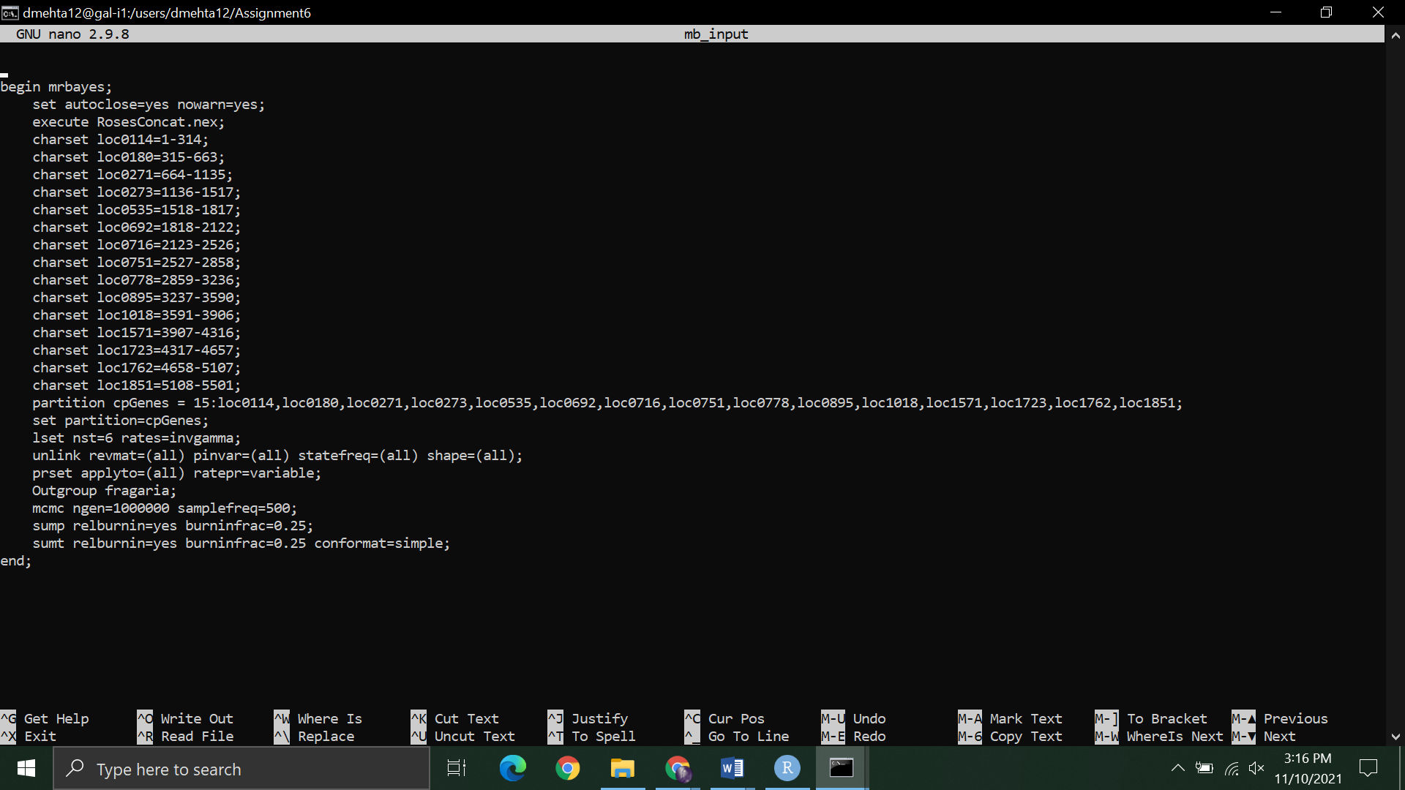

Fig 1a: mb_input file containing information about the parameters and partitions.

mb_input file:

begin mrbayes;

set autoclose=yes nowarn=yes;

execute RosesConcat.nex;

charset loc0114=1-314;

charset loc0180=315-663;

charset loc0271=664-1135;

charset loc0273=1136-1517;

charset loc0535=1518-1817;

charset loc0692=1818-2122;

charset loc0716=2123-2526;

charset loc0751=2527-2858;

charset loc0778=2859-3236;

charset loc0895=3237-3590;

charset loc1018=3591-3906;

charset loc1571=3907-4316;

charset loc1723=4317-4657;

charset loc1762=4658-5107;

charset loc1851=5108-5501;

partition cpGenes = 15:loc0114,loc0180,loc0271,loc0273,loc0535,loc0692,loc0716,loc0751,loc0778,loc0895,loc1018,loc1571,loc1723,loc1762,loc1851;

set partition=cpGenes;

lset nst=6 rates=invgamma;

unlink revmat=(all) pinvar=(all) statefreq=(all) shape=(all);

prset applyto=(all) ratepr=variable;

Outgroup fragaria;

mcmc ngen=1000000 samplefreq=500;

sump relburnin=yes burninfrac=0.25;

sumt relburnin=yes burninfrac=0.25 conformat=simple;

end;

Additional slurm file:

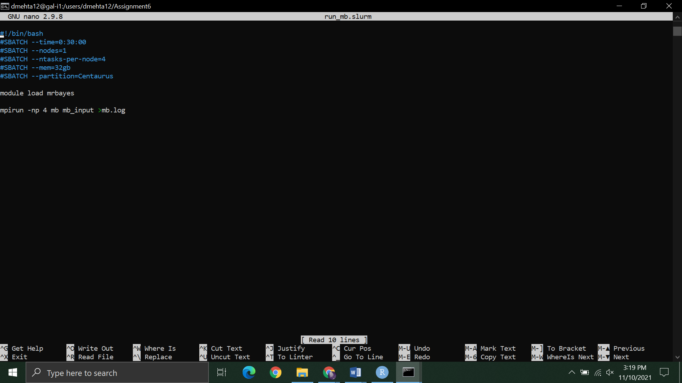

Fig 1b: run_mb.slurm file code

run_mb.slurm file:

#!/bin/bash

#SBATCH --time=0:30:00

#SBATCH --nodes=1

#SBATCH --ntasks-per-node=4

#SBATCH --mem=32gb

#SBATCH --partition=Centaurus

module load mrbayes

mpirun -np 4 mb mb_input >mb.log

**Question 2: Do the values in your .pstat file suggest that the MCMC achieved convergence? Why or why not? (2 pts)**

A)

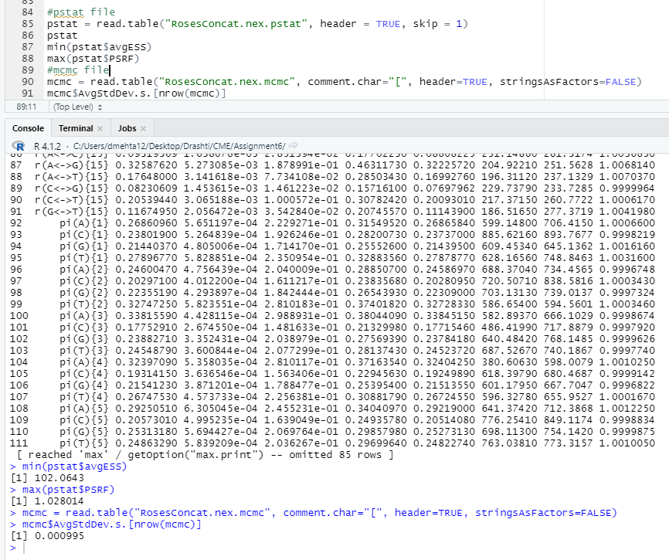

Fig 2: ESS, PSRF and SD values - table

We take 3 things into account here, ESS value, PSRF value and standard deviation values.

From the image shown above, the minimum value of ESS is 102.0643 which is above 100, the maximum value for PSRF is 1.028 which is less than 1.1 and the value for SD is 0.000995 which is less than 0.01. Hence, we can conclude that the MCMC has achieved convergence.

**Q3: Provide a plot of your consensus tree from MrBayes with posterior probability values at each node. (3 pts)**

A)

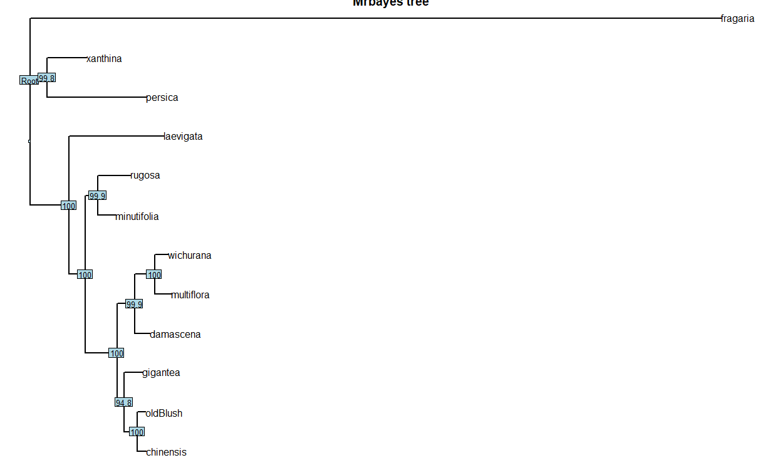

Fig 3: Mrbayes tree with bootstrap values

Q4: Provide a plot of your ASTRAL tree with posterior probability values at each node. (3 pts)

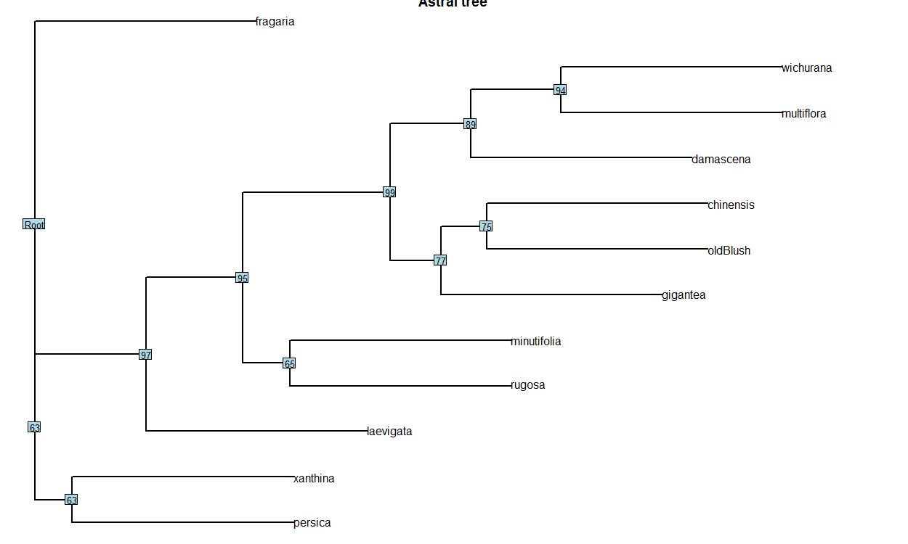

Fig 4: Astral tree with bootstrap values

**Q5: Perform a comparison of your ASTRAL tree and your MrBayes tree. Are they identical, or are there some differences in terms of the tree topologies? (1 pt)**

A) When we look at both the trees (ref fig 3 and fig 4), it can be seen that the clade closest to the outgroup in mrbayes tree (xanthina and persica) is the farthest when it comes to the astral tree. The clades for all the species are the same but the arrangement is different in both the trees. The posterior probability values are also differing when we look at both the trees. For example, the lowest bootstrap value for Mrbayes tree is 94.8 at the node of clades gigantea and (chinensis + old blush) while that for Astral tree is at the node of clade Xanthina and Persica.

**Q6: The Old Blush rose was one of the earliest varieties of cultivated rose (it has been around for roughly 1,000 years!). It is also probably the first cultivated rose ever introduced to Europe. Based on your phylogeny, where does this rose come from? (Hint: what is its closest relative?). (1 pt)**

A)

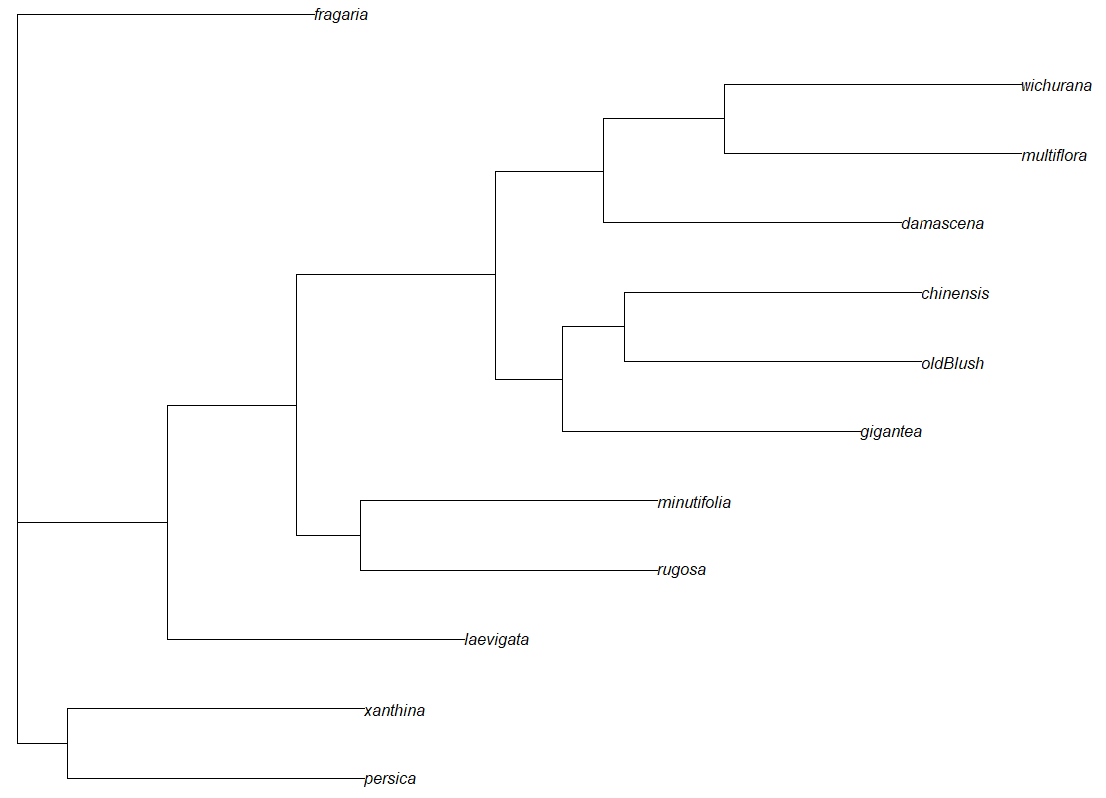

Fig 6: Astral tree (without bootstrap values)

From the phylogenetic tree, we understand that the Old Blush falls under the clade with Chinensis (China rose), which comes from China. Based on the phylogenetic tree, we infer that as the closest relative of Old Blush, Chinensis, comes from China, it also would have come from China.